June 2018

An Introduction to Deep-Sequencing Data Analysis

Exercise #1 Introduction to Linux and WEXAC cluster

Dena Leshkowitz and Ester Feldmesser

Introduction

In this workshop we will learn how to use the cluster WEXAC and write commands in Linux through a terminal.

Supplementary information is found at the end of the document.

Commands you are requested to type appear in italic font.

Instructions

Accessing the WEXAC server by opening a terminal

MobaXterm is an enhanced terminal for Windows with X11 server, tabbed SSH client, network tools and much more. MobaXterm is useful for working on linux servers. It is available for free download at: http://mobaxterm.mobatek.net/download.html
No need to do this now since it is already installed in the class.

Find the MobaXterm icon on your desktop and click to open.
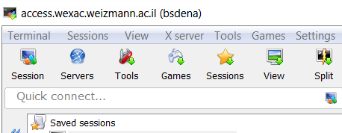

Click on session (red arrow), then select SSH, the following window will open:

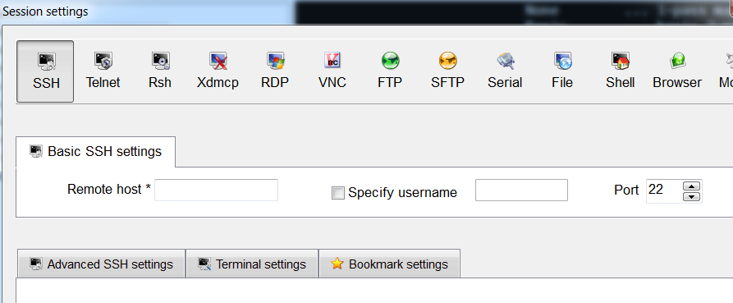
You are prompted to insert the host (server) name – access.wexac.weizmann.ac.il and the username – please ask us for your username and password. Then in the terminal you will be requested to enter the password.

Learning Basic Unix/Linux commands

In order to list all the files and folders in your home directory (your current folder location), type:
ls

To get more information on this command type:

man ls

The man command lists all available parameters on the command of interest. To exit the manual, type: q.

For more commands, look at the supplementary section #2 at the end of the document.

To get more information on the files type:

ls -l

To move into the course_2018 directory type:

cd course_2018

Editing a text file

Return to your home directory:
cd ~
Create an empty file by typing:
touch my_file

MobaXterm has a build-in editor. From the Sftp window (appears as a tab on the left pane of MobaXterm window), you can right click a text or an empty file name and open it in a new window with the default text editor (figure at the right). The editor window will work as a regular PC window.

Open the empty file that you created by double clicking on the Sftp window, write on it “This is my new file” and save it back in the same place (directory).
In the shell window (right pane), use the more command to view what you have written in the file.

Loading modules to your environment

With the help of the Environment Modules package it is possible to dynamically
modify your environment on the wexac cluster in order to be able to run particular software packages. We will load the modules that open the IGV browser.
(to learn more about IGV browser, look here: http://software.broadinstitute.org/software/igv/home). We will be using this tool a lot during the course.
Please type all the commands:
module load IGV
module load jre
igv.sh

This will take a few minutes. Please wait until the application’s window opens. Just close it for now.

Running a job on the WEXAC cluster

The Wexac cluster is built from many host servers, the access server that we will be using, is just one of them. In order to send a job to the cluster so that it will run on one of the hosts available, use the bsub command (supplementary section #3). Following is an example for a command that will delay for 5 seconds and then will type the date in a file named date.txt:

cd ~
bsub -q new-short -J mydat -o mydat_log.txt -e mydate_error.txt 'sleep 5;date>date.txt'

You should get lines similar to:
Memory reservation is (MB): 2048
Memory Limit is (MB): 2048
Job <363927> is submitted to queue <new-short>

To see a job’s status type (see options in supplementary section #4):
bjobs

Continue to type bjobs every few minutes until you get the message “No unfinished job found”

Then to see the file that was created, type
more date.txt

List the files that you created by using ls –l. Use the rm (remove) command to clean your home directory from all four files you have just created with the following command (change filename with the relevant names).

rm filename

Supplementary

WEXAC introduction presentation

http://www.weizmann.ac.il/DIS/sites/DIS/files/uploads/it/files/wexac_introduction.pdf

Basic Linux commands:

man (command) ...... shows help on a specific command
ls ................. show directory, in alphabetical order
logout ............. logs off system
mkdir .............. make a directory
rmdir .............. remove directory (rm -r to delete folders with files)
rm ................. remove files
cd ................. change current directory
more .............. views a file, pausing every screenful
grep ............... search for a string in a file
head ............... show the first few lines of a file
tail ............... show the last few lines of a file
df ................. shows disk space available on the system
du ................. shows how much disk space is being used up by folders
chmod .............. changes permissions on a file
cut ............... print selected parts of lines
cp ............... copy file
mv ............... move file
wc –l .............. print the number of lines
sort ............. sort lines of text files

bsub - Commonly Used Options
-q qname submits the job to the specified queue
-o file redirect stdout, stderr and resource usage information of the job to the specified output file
-e file redirect stderr to the specified error file
-oo/-eo file same as -o/-e, but overwrite file if it exists
-i filename, use the specified file as standard input for the job
-n number, specify number of job slots
-g jobgroup submit job to specified group
-J jobname assigns the specified name to the job
-R res_req runs job on a host that meets the specified resource requirements

bjobs - View Job Information
-a Display information about jobs in all states, including recently finished jobs
-A Displays summarized information about job arrays
-d Display information about jobs that finished recently
-l|-w Display information in long or wide format
-p Display information about pending jobs
-r Display information about running jobs
-g job_group Display information about jobs in specified group
-J job_name Display information about specified job or array
-q queue Display information about jobs in specified queue
-u user Display information about jobs for specified users/groups

