June 2017

An Introduction to Deep-Sequencing Data Analysis

Exercise #5: Learn how to detect and cluster differentially expressed genes from RNA-Seq data using DESeq2

Dena Leshkowitz & Ester Feldmesser

Introduction
In previous exercises we performed QC, and mapping of RNA-Seq data from an experiment performed in Arabidopsis. For the purpose of the exercise, we chose 4 time points for which we have biological duplicates. In this exercise we will run the DESeq2 package in R in order to detect genes that are differentially expressed between day 8 and the other days.

Answers for exercise 3 are found at- http://dors.weizmann.ac.il/course/AnswersForExercise3.docx

Instructions

Part 1

We will run R on WEXAC using the Rstudio application.
In a browser type the following URL and enter your class user and password.
Class 1-10 use https://appsrv.wexac.weizmann.ac.il/rstudio/auth-sign-in
Class 11-20 use https://appsrv.wexac.weizmann.ac.il/rstudio2/auth-sign-in
Class 20-40 use https://appsrv.wexac.weizmann.ac.il/rstudio3/auth-sign-in
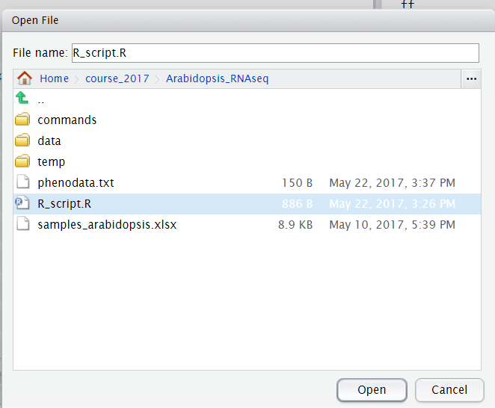

Open the file menu and click to load the R script found under ~/course_2017/Arabidopsis_RNAseq, as shown below:

This script loads the DESeq2 package and runs the DESeq2 functions.
Place the cursor on the first line and click on the run (or press Ctrl+Enter):

The lines that start with # are comments – not a command.

Run all the command lines up to line 27.

In the right panel you can see the objects that you created (as below)

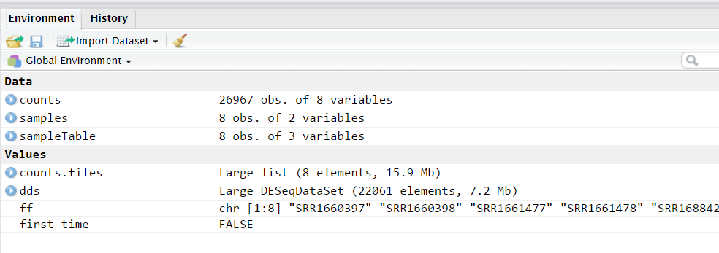
To see the counts matrix you can click on counts.

Question 1: Look at the dimensions of the counts object and answer: for how many genes do we have counts?

After running the following command: dds <- dds[ rowSums(counts(dds)) > 1, ]

Question 2: How many genes were removed from the dds object?

After running the command as.data.frame(colData(dds))

You should see the following:
sampleName filename day sizeFactor
SRR1660397 SRR1660397_day_8 SRR1660397 day_8 0.8623796
SRR1660398 SRR1660398_day_8 SRR1660398 day_8 1.3021275
SRR1661477 SRR1661477_day_11 SRR1661477 day_11 1.2983530
SRR1661478 SRR1661478_day_11 SRR1661478 day_11 0.9176669
SRR1688427 SRR1688427_day_16 SRR1688427 day_16 1.0152485
SRR1688429 SRR1688429_day_16 SRR1688429 day_16 1.0000384
SRR2073179 SRR2073179_day_12 SRR2073179 day_12 0.8152082
SRR2106520 SRR2106520_day_12 SRR2106520 day_12 0.9963450

Question 3:
Observing the size factors, which sample has the highest number of counts? Hint for normalization, counts are divided by size factor.

The command as.data.frame(colSums(counts(dds,normalized=FALSE))), will help you understand if you answered correctly.

To open the report file you created, return to MobaXterm window. On the left there is a sftp pane, set the location to the required path to reach the report file (see below red arrow), right click on the report file and select the option “Download”. Open the file with Excel. Make sure to define the first column that contains the gene symbol names as text, see below. This step is important since some gene names are otherwise interpreted as dates and are changed by Excel.

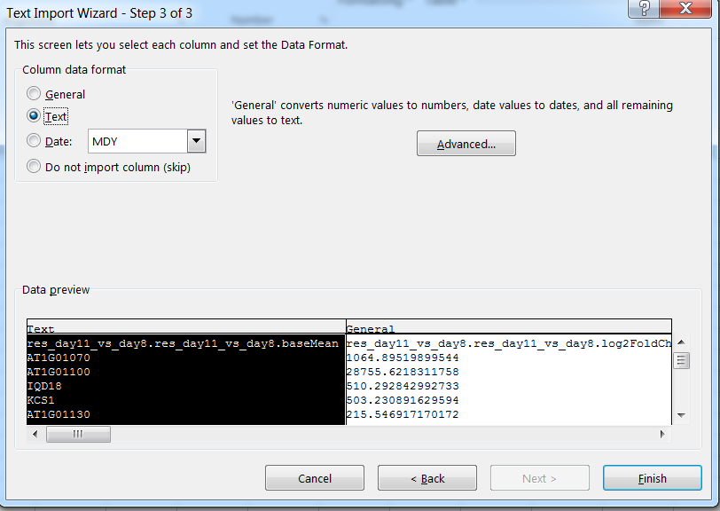

There is a need to shift the first cell of the header to the right.

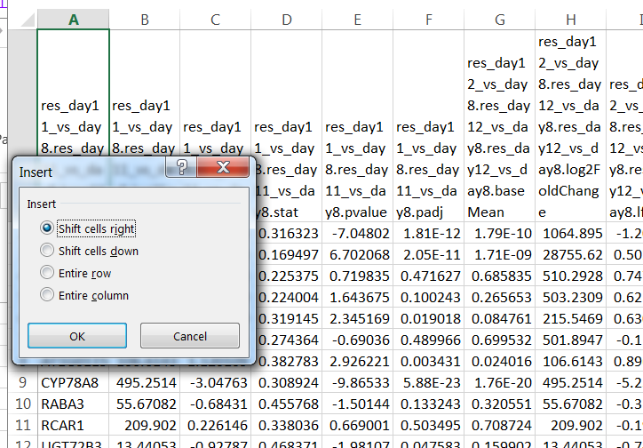

You are now ready for the second part of the exercise.

Part2
The second part of the exercise will include exploratory analysis, to learn about the relationship between the samples (replicates and different conditions) and clustering of the differentially expressed genes that will be used later for functional analysis.

Exploratory analysis

In this part you will continue performing the commands that appear in the script, for the exploratory analysis, we will build a matrix of correlations between the samples, note that the correlations are clustered, and then we will perform hierarchical clustering of the samples using Pearson’s dissimilarity. Last, we will plot a principal component analysis (PCA).

Question 4: Which samples are close to each other? Are these duplicates?
If you don’t remember the names of the samples, you can click on the sampleTable as you did before for counts.

Clustering of differentially expressed genes

The differentially expressed genes will be clustered using k-means. The values used as input for the clustering are normalized log values for DE genes. The optimal number of clusters to be used in k-means needs to be determined and this task is not trivial, if we choose too little clusters, they will be very heterogeneous, if we choose too much, they will over fit the data.

From https://www.r-bloggers.com/finding-optimal-number-of-clusters/:
“The elbow method looks at the percentage of variance explained as a function of the number of clusters: One should choose a number of clusters so that adding another cluster doesn’t give much better modeling of the data. More precisely, if one plots the percentage of variance explained by the clusters against the number of clusters, the first clusters will add much information (explain a lot of variance), but at some point the marginal gain will drop, giving an angle in the graph. The number of clusters is chosen at this point, hence the “elbow criterion”. This “elbow” cannot always be unambiguously identified.”

The parameter we will look at in the plot of the exercise is the within clusters sum of squares (an estimate of the variance inside the clusters) and it should be smaller as we add clusters. This estimate is negatively correlated to the variance explained and can be used instead.

Question 5: Can you identify clearly the optimal number of clusters? Which number/s do you suggest to try?

Question 6: What part of the variance is explained with 3 clusters?

Question 7: Do 4 clusters look better (more homogeneity inside clusters) than 3? Answer just by looking by eye at the k-means with 3 or 4 clusters.

Supplementary

DESeq2 vignettes (manual)
https://bioconductor.org/packages/release/bioc/vignettes/DESeq2/inst/doc/DESeq2.html#summarizedexperiment-input

DESeq2 example of workflow http://www.bioconductor.org/help/workflows/rnaseqGene/

Elbow method to determine the number of clusters in k-means
https://www.r-bloggers.com/finding-optimal-number-of-clusters/

