June 2017

An Introduction to Deep-Sequencing Data Analysis

Exercise #3: Analyzing RNA-Seq data

Dena Leshkowitz

Introduction
We will analyze RNA-Seq data from an experiment performed in Arabidopsis. The data was downloaded from the public domain, see the following link for more details: https://www.ncbi.nlm.nih.gov/pubmed/26084880.
In the previous exercise we ran FASTQC and STAR. In this exercise we will observe the outputs produced by them. If you did not finish running STAR please do so now.

Answers to Exercise 2 are found here http://dors.weizmann.ac.il/course/AnswersForExercise2.docx

Instructions

- FASTQC results
View the reports you produced and decide if the sequences are of sufficient quality.

- STAR results
STAR produces several outputs as you can see if you list the files in your folder.
  - The files that end with “Log.final.out” contain summary mapping statistics and they are very useful for quality control.
Question: How many reads did each sample have and how many were mapped uniquely?

To view the output, type:
(the “*” is termed wildcard and means any character):

more *Log.final.out

  - The file ReadsPerGene.out.tab contains STAR read counts per gene. In the output there are 4 columns which correspond to different library protocols strand options:
    - column 1: gene ID
    - column 2: counts for unstranded RNA-seq
    - column 3: counts for the 1st read strand aligned with RNA (htseq-count option -s yes)
    - column 4: counts for the 2nd read strand aligned with RNA (htseq-count option –s reverse)

Question: How many genes are represented in the file? Hint- each line except the first lines in the files are counts per gene, you should use a Linux command for the answer (look at supplementary section)

  - Alignment files
STAR can output alignments directly in binary BAM format according to the parameters we used. BAM files are sorted by coordinates. We will first index them so that we would be able to load them to a viewer. Type:

module load samtools
module load python/2.7.13
samtools index

The last command will return the instructions for the command

Type the command to send the job to the cluster:
bsub -q bio-guest -R "rusage[mem=10000]" "samtools index SRR1660397Aligned.sortedByCoord.out.bam"

Repeat this for all the bam files.

  - View Alignment on a genome browser
Open IGV (see exercise 1 or supplementary section)
module load IGV
module load jre
igv.sh

Change the genome to Arabidopsis TAIR10, click on the scroll see red arrow below

Load a bam file by selecting it using the File menu.
Note: select only a bam file that has also an index file (*.bai). Do not select the index files.

Now we want to zoom into a region of expression such as gene AT1G01100. Enter the gene name – see arrow.

Following is an explanation of the features of IGV:

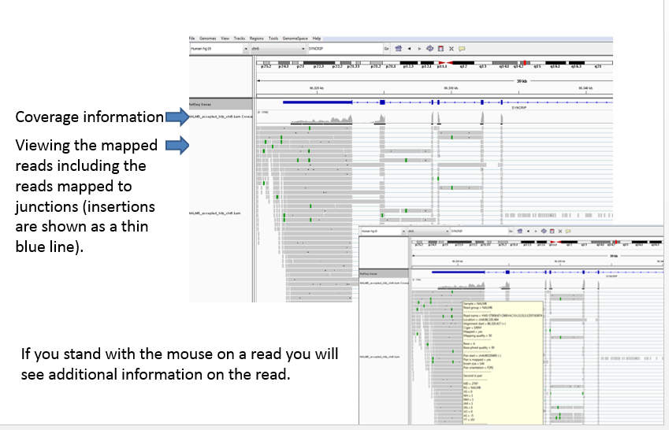

Good job. You completed this exercise.

Supplementary

STAR manual

https://github.com/alexdobin/STAR/blob/master/doc/STARmanual.pdf

IGV user guide

http://software.broadinstitute.org/software/igv/userguide

Basic Linux commands:

man (command) ...... shows help on a specific command
ls ................. show directory, in alphabetical order
logout ............. logs off system
mkdir .............. make a directory
rmdir .............. remove directory (rm -r to delete folders with files)
rm ................. remove files
cd ................. change current directory
more .............. views a file, pausing every screenful
grep ............... search for a string in a file
head ............... show the first few lines of a file
tail ............... show the last few lines of a file
df ................. shows disk space available on the system
du ................. shows how much disk space is being used up by folders
chmod .............. changes permissions on a file
cut ............... print selected parts of lines
cp ............... copy file
mv ............... move file
wc –l .............. print the number of lines
sort ............. sort lines of text files

